Active Directory

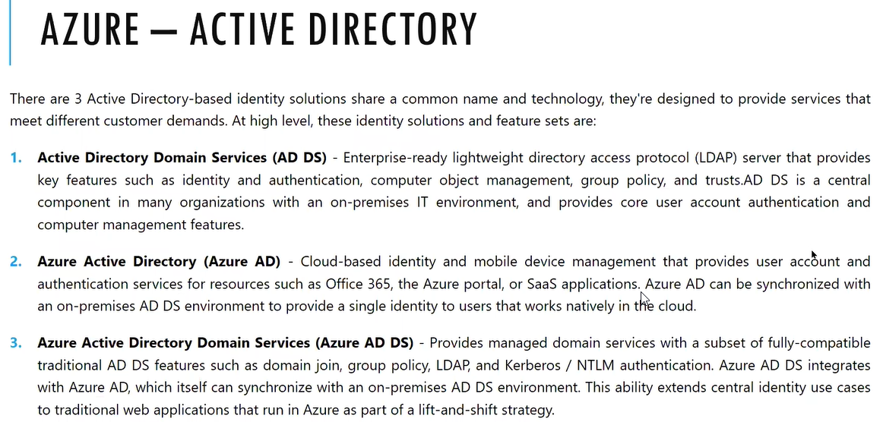

Every employee has machines and along they have logins. The whole organization must manage its logical entity we will use Activity directory

To authentic the users in the organization we will use the Azure activity directory

ATMS will use authentication server (Centralized mechanism server is in the main which is located In delhi which will manages all the ATMs /decentralized mechanism millions of user database in every ATM machine inside we need to save in local database which is a difficult task)

For example, there are 100 employees which is not in centralized way, so we need to bring it as centralized way

100 employees working in the shift as A, B and c in which it is allocated as 40 machines

We need to save 100 employee data in all the 40 machines locally we need to create the user accounts

If any employee has updated the password, we need to update in all the 40 machines which is a difficult task or if employee has left, we need to disable the user account in all 40 machines with out active directory we are doing this to overcome this we need maintain active directory server

It is a main database, login database. In activity server we will create the user account for all the employees, and he will login to the individual computer. Individual computers they will make as a domain members active directory member they will join it and for join every computer one relationship it will communicate to active directory

Will join each desktop and laptop in the active directory we will see two options in the login local database

In the machine local database, user accounts can login

Active directory database user accounts also we can login

Active directory server in the network joined machines for all the employee’s employee can login into that.

Drivers, printers will be published in Active directory server they will share like a network interface

They will query and they will get access to active directory

Active directory will be stored in windows server not in windows 10 operating sytem

If you want to convert the machine from active directory server to on premises like windows 12, 14 server we need to go to server manager

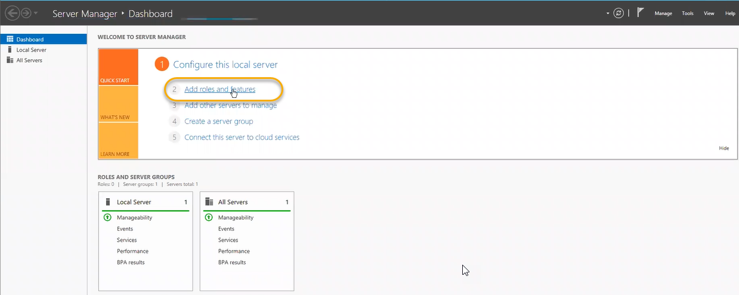

We need to click on the Next > Next > Next

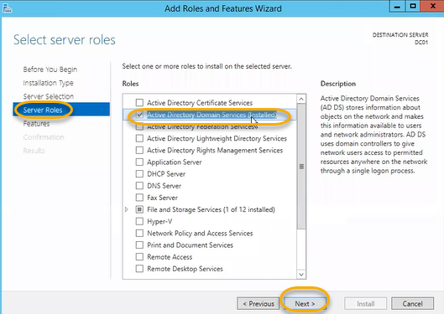

We are converting this machine to Active directory server

Once installed we see the flag

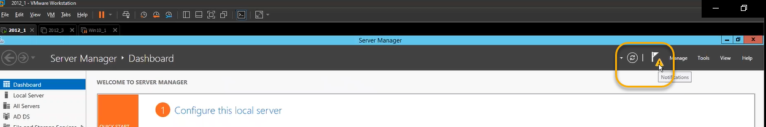

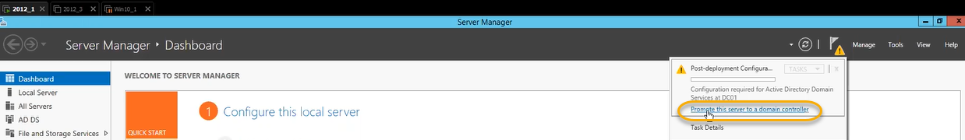

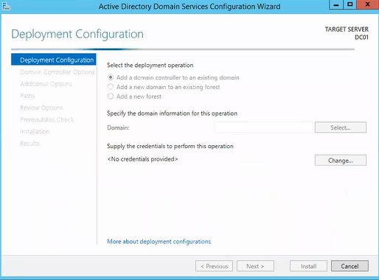

Computer management > in this machine locally created user account we can see

Or we can check this in control panel

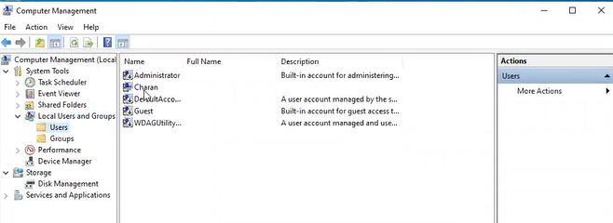

If this machine wants to access the active directory user account we need to join to active directory then inside the active directory using the user account we can login to this machine

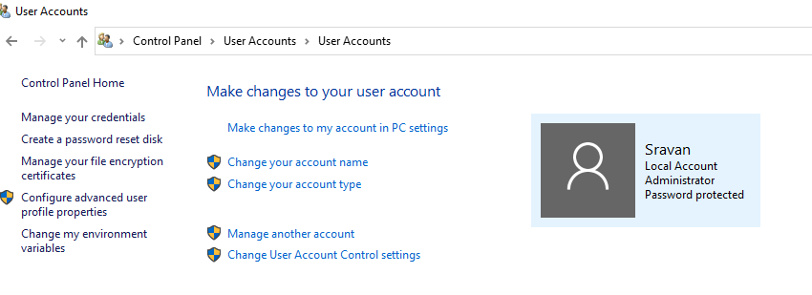

This client machine we need to join the active directory to login

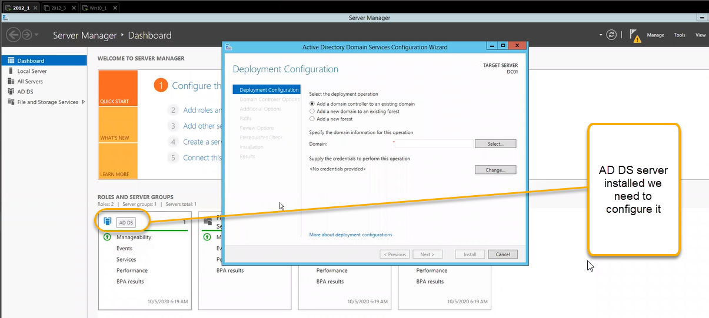

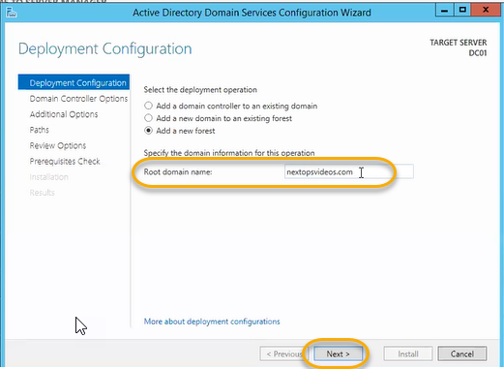

Forest functional and domain which windows server the organization is supporting if you select the latest server more features will support

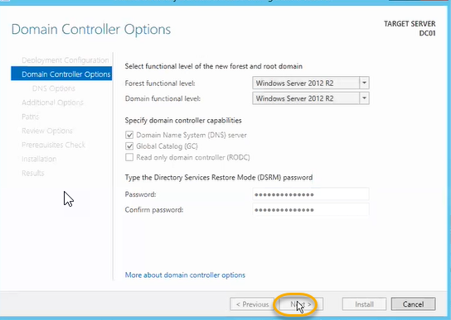

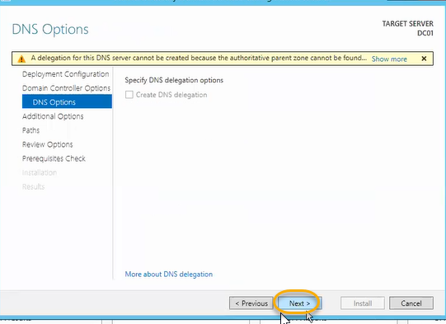

There will be namespace for the organization to manage the user accounts

Namespace is nothing but domain name (Created user accounts/Join machines everything we can see the same namespace)

If join the machine for client 01 then we can see the client [01@nextopsvideo.com](mailto:01@nextopsvideo.com)